Python – Backend Assignment

**Module 1 – Overview of IT Industry**

1. **What is a Program?**

**Ans.** A **program** is a set of instructions written in a programming language that tells a computer what to do.

1. **Explain in your own words what a program is and how it functions.**

**Ans.** A program is a set of written instructions that tells a computer how to perform specific tasks.

It works by being translated into machine code the computer can understand.

1. **What is Programming?**

**Ans.** programming is how humans **communicate with computers** to make them do useful things.

1. **What are the key steps involved in the programming process?**

**Ans.** 1. Requirement Gathering

2. Analysis

3. Designing

4. Implementation

5. Testing

6. Maintenance

1. **Types of Programming Languages.**

**Ans.** 1. Procedural Programming Language

Ex: C Language

2. Object Oriented Programming Language

Ex: C++ Language

3. Logical Programming Language

Ex: Prolog Language

4. Functional Programming Language

Ex: Python Language

1. **What are the main differences between high-level and low-level programming languages?**

**Ans.**

| * High Level Programming Language | * Low-level Programming Language |
| --- | --- |
| * Requires Compiler or Interpreter to convert into Machine Language * Easy to Read, write and Understand * Slower (needs compiler/interpreter translation) * Ex: Procedural & Object Oriented Programming Language | * It Runs through Compiler or Interpreter * Difficult to read, requires hardware knowledge * Faster (direct communication with hardware) * Ex: Machine & Assembly language. |

1. **World Wide Web & How Internet Works**

**Ans.**  A collection of websites and pages you can access through the internet using browsers like Chrome. It connects millions of computers worldwide, allowing them to share information by sending data back and forth.

1. **Research and create a diagram of how data is transmitted from a client to a server over the internet.**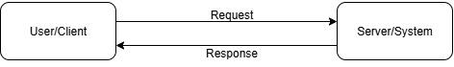

**Ans.**

1. **Describe the roles of the client and server in web communication.**

**Ans.** **Client:** The client is the user’s device (e.g., browser, app) that sends requests to the server for data.

**Server:** The server processes requests from clients and sends the requested data back (e.g., web pages ,files).

1. **Network Layers on Client and Server**

**Ans.** The **TCP/IP model** has 4 layers:

1. **Application**: Interacts with the user.
2. **Transport**: Manages data flow.
3. **Internet**: Routes data.
4. **Link**: Transmits data physically.
5. **Explain the function of the TCP/IP model and its layers.**

**Ans.** The **TCP/IP model** is a framework that standardizes communication over a network. It has four layers:

* **Application Layer:** Handles application-level communication (e.g., HTTP, FTP).
* **Transport Layer:** Manages end-to-end communication (e.g., TCP, UDP).
* **Internet Layer:** Routes data packets (e.g., IP).
* **Link Layer:** Handles physical network connections (e.g., Ethernet).

1. **Explain Client Server Communication**

**Ans.** **Client-server communication** is how two computers (or devices) talk over a network:

* **Client**: The device or program that requests a service (like a web browser asking for a website).
* **Server**: The device or program that provides the service (like a web server sending the webpage).

1. **Research different types of internet connections (e.g., broadband, fiber, satellite) and list their pros and cons**

**Ans.** **Broadband**: Fast, widely available, but slower than fiber.

**Fiber-optic**: Very fast, but more expensive and not available everywhere.

**Satellite**: Available anywhere, but slower and with higher latency.

| **Connection Types** | **Pros** | **Cons** |
| --- | --- | --- |
| Broadband | Widely available, affordable, fast | Speeds vary, shared bandwidth |
| Fiber Optic | Very fast, reliable, low latency | Expensive, limited availability |
| Satellite | Available anywhere, no physical infrastructure | High latency, slow speeds, weather issues |

1. **How does broadband differ from fiber-optic internet? Protocols**

**Ans.** **Broadband:** General term for high-speed internet. It can use various technologies (DSL, cable, satellite).

**Fiber-Optic:** Uses light signals over glass fibers to transmit data, offering much fasterspeeds and lower latency compared to broadband.

1. **What are the differences between HTTP and HTTPS protocols?**

**Ans.** **HTTP:** Hypertext Transfer Protocol, sends data in plain text and is less secure.

**HTTPS:** Secure version of HTTP, uses SSL/TLS encryption to protect data during transmission.

1. **Identify and explain three common application security vulnerabilities. Suggest possible solutions.**

**Ans.**

| **Vulnerability** | **Explanation** | **Possible Solutions** |
| --- | --- | --- |
| **SQL Injection** | Attackers insert malicious SQL code into input fields to access or manipulate the database. | - Use prepared statements and parameterized queries.  - Validate and sanitize user input. |
| **Cross-Site Scripting (XSS)** | Malicious scripts are injected into web pages and run in users’ browsers, stealing data or performing actions. | - Escape user input before displaying it on web pages.  - Use Content Security Policy (CSP). |
| **Insecure Authentication** | Weak login mechanisms allow attackers to gain unauthorized access. | - Use strong password policies.  - Implement multi-factor authentication (MFA).  - Limit login attempts. |

1. **What is the role of encryption in securing applications?**

**Ans.** **Encryption** ensures that data is converted into a secure format, making it unreadable to unauthorized users. It protects sensitive information (e.g., passwords, credit card details) from being intercepted during communication.

1. **Identify and classify 5 applications you use daily as either system software or application software.**

**Ans. System Software - Device Drivers & System Software**

**Software application - Music, Message, Web Browser.**

1. **What is the difference between system software and application software?**

**Ans.** **System Software:** Includes operating systems and utilities that manage hardware (e.g., Windows, Linux).

**Application Software:** Programs designed to perform specific tasks for the user (e.g., Microsoft Word, Google Chrome).

1. **Design a basic three-tier software architecture diagram for a web application.**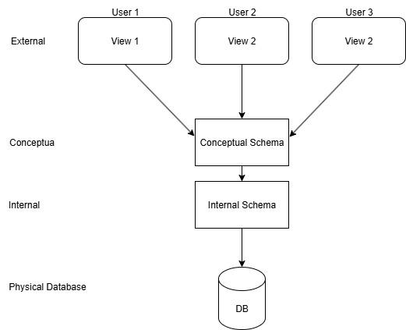

**Ans.**

1. **What is the significance of modularity in software architecture?**

**Ans.** **Modularity** allows breaking down software into smaller, reusable, and maintainable components. This makes the software easier to develop, test, and update.

1. **Why are layers important in software architecture?**

**Ans.** **Layers** in software architecture help organize code logically, making it easier to manage, scale, and maintain. They separate concerns, such as user interface, business logic, and data management.

1. **Explore different types of software environments (development, testing, production)**

**Ans.** The **development environment** provides the necessary tools, libraries, and settings for developers to write, test, and debug code. It ensures consistency and efficiency in the development process.

**1. Development Environment**

Purpose: Where developers write, build, and test their code.

Users: Software developers.

Features:

Includes tools like code editors, compilers, debuggers.

Frequent changes and testing happen here.

**Example:** A local machine with Visual Studio Code and a local database.

**2. Testing Environment**

Purpose: Used to test the application before releasing it to users.

Users: QA (Quality Assurance) testers.

Features:

Simulates real-world scenarios to check for bugs or errors.

Separate from development to avoid conflicts.

**Example:** A server set up with the full application and test data.

**3. Production Environment**

Purpose: The live environment where real users access the application.

Users: End users/customers.

Features:

Most stable version of the application.

Performance, reliability, and security are key.

**Example:** A public-facing website like an online store.

1. **Explain the importance of a development environment in software production.**

**Ans.**

A development environment is where developers write, build, and test code before it's moved to testing or production. It is a critical part of the software development process.

it’s importance-

* Safe Coding Space

Developers can experiment, write, and debug code without affecting users or the live application.

* Version Control Integration

Helps manage changes in the code and collaborate with team members efficiently.

* Early Bug Detection

Bugs and issues can be found and fixed early, saving time and cost later.

* Tool Support

It includes tools like IDEs, debuggers, and compilers that improve productivity.

* Testing Features Quickly

New features can be tested in isolation before going to staging or production.

1. **What is the difference between source code and machine code?**

**Ans.** **Source Code:** Human-readable code written in a programming language.

**Machine Code:** Low-level code (binary) that a computer's processor understands.

1. **Why is version control important in software development?**

**Ans.** Version control allows developers to track changes in code, collaborate effectively, and roll back to previous versions if necessary. It helps prevent conflicts and ensures project consistency.

1. **What are the benefits of using Github for students?**

**Ans.** GitHub offers students a platform to manage code, collaborate on projects, showcase work, and learn version control. It also facilitates teamwork and allows access to a wide range of open-source projects.

1. **What are the differences between open-source and proprietary software?**

**Ans.** **Open-Source:** The source code is available for anyone to view, modify, and distribute (e.g., Linux).

**Proprietary:** The source code is owned and controlled by the developer, and its use is restricted (e.g., Windows).

1. **How does GIT improve collaboration in a software development team?**

**Ans.** **Git** allows multiple developers to work on the same codebase simultaneously, track changes, resolve conflicts, and merge contributions without overwriting others’ work.

1. **Write a report on the various types of application software and how they improve productivity.**

**Ans.** Application software refers to programs designed to perform specific tasks for users. These applications help individuals and businesses carry out their daily tasks more efficiently, ultimately increasing productivity.

| **Types** | **Examples** | **Ways to Improves** |
| --- | --- | --- |
| Word Processing Software | Word Processing Software | Helps create, edit, and format documents quickly and professionally. |
| Spreadsheet Software | Microsoft Excel, Google Sheets | Automates calculations, analyzes data, and manages records easily. |
| Database Software | Microsoft Access, MySQL | Organizes and retrieves large volumes of data efficiently. |
| Web Browsers | Google Chrome, Mozilla Firefox | Provides access to information, tools, and services online. |

1. **What is the role of application software in businesses?**

**Ans.** **Application software** helps businesses perform tasks more efficiently, such as accounting, communication, and data management, ultimately improving productivity and decision-making.

1. **Create a flowchart representing the Software Development Life Cycle (SDLC).**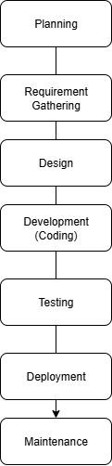

**Ans.**

1. **What are the main stages of the software development process?**

**Ans.**

1. Requirement Gathering: Understand what needs to be built.
2. Design: Create a blueprint for how the system will work.
3. Implementation: Write the code.
4. Testing: Verify the software works as expected.
5. Deployment: Release the software to users.
6. Maintenance: Update and fix any issues after release.
7. **Write a requirement specification for a simple library management system**

**Ans.**

**1. Purpose**

* To manage books, members, borrowing, and returning activities in a library.
* To reduce manual work and make the process easier and faster.

#### **2. Functional Requirements (What the system should do)**

* The system should allow the admin to add, update, and delete books.
* Members should be able to register and update their details.
* Members should be able to borrow and return books.
* The system should track due dates for each borrowed book.
* The system should show a list of overdue books.
* Users should be able to search books by title, author, or category.
* The system should prevent a member from borrowing if they have overdue books.

#### **3. User Roles**

* Admin:  
  + Add and manage books.
  + Register and manage members.
  + View borrowed and returned books.
* Member:  
  + Search for books.
  + Borrow and return books.

#### **4. Non-Functional Requirements (System Qualities)**

* The system should be easy to use and understand.
* It should respond quickly (within a few seconds).
* All data should be stored safely and regularly backed up.
* The system should be available most of the time (high uptime).

#### **5. Technical Requirements (Optional)**

* The system can be a web or desktop application.
* It can use simple tools like Python or Java for development.
* A small database like MySQL or SQLite can be used to store data.

1. **Why is the requirement analysis phase critical in software development?**

**Ans.** Requirement analysis ensures that the software meets the user’s needs. It helps identify features, constraints, and potential issues early, minimizing costly changes during development.

1. **What is the role of software analysis in the development process?**

**Ans.** Software analysis involves understanding the problem to be solved, gathering user requirements, and breaking down the system’s components, ensuring the design meets the desired objectives.

1. **What are the key elements of system design?**

**Ans.** **Architecture Design:** High-level structure.

**Component Design**: Breakdown of individual components.

**Interface Design:** How different components interact.

1. **Why is software testing important?**

**Ans.** Software testing ensures that the program works as expected, identifies bugs, and prevents issues that could affect users or cause failures.

1. **What types of software maintenance are there?**

**Ans.** **Corrective:** Fixing errors and bugs.

* **Adaptive:** Updating the system for changes in the environment.
* **Perfective:** Enhancing performance or features.
* **Preventive:** Proactively preventing issues from occurring.

1. **What are the key differences between web and desktop applications?**

**Ans.** **Web Applications:** Run in a browser, accessible via the internet.

**Desktop Applications:** Installed and run directly on the computer without needing a browser.

1. **What are the advantages of using web applications over desktop applications?**

**Ans.** Web applications are accessible from any device with a browser, don’t require installation, and are easier to update. Desktop apps can be more feature-rich but require installation and updates on each machine.

1. **What role does UI/UX design play in application development?**

**Ans.** **UI/UX design** focuses on creating user-friendly interfaces and ensuring a seamless user experience. Good design increases user satisfaction and engagement.

1. **What are the differences between native and hybrid mobile apps?**

**Ans.** **Native Apps:** Built for specific platforms (e.g., iOS, Android) and provide better performance.

**Hybrid Apps:** Cross-platform apps that run on multiple devices but may have lower performance.

1. **Create a DFD for a hospital management system**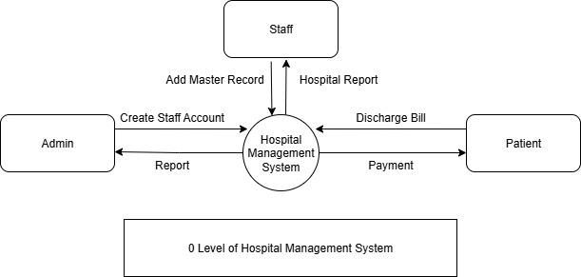

**Ans.**

1. **What is the significance of DFDs in system analysis?**

**Ans.** **Data Flow Diagrams (DFDs)** visualize how data moves through a system, helping to understand processes, inputs, outputs, and how the system functions

1. **What are the pros and cons of desktop applications compared to web applications?**

**Ans.** **Desktop Apps:** Higher performance and offline functionality, but require installation and updates.

**Web Apps:** Accessible from any device with a browser, no installation required, but dependent on internet access.

1. **Draw a flowchart representing the logic of a basic online registration system.**

**Ans.** 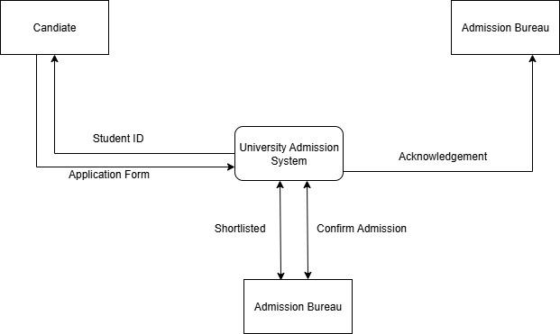

1. **How do flowcharts help in programming and system design?**

**Ans.** **Flowcharts** visually represent the logic and flow of a program, making it easier to understand, communicate, and debug the design.